A World To Win

March 31, 2010

A model for political theatre
It is hard to believe that there is better acting to be seen anywhere on the London stage, in a play with a more important intent. Penny Cole reviews A Model for Mankind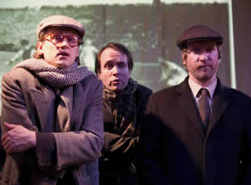
Richard Keightley (Shostakovich), Jack Lewis (Strelyenko)
& Paul Brendan (Albedov)
This excellent ensemble bring to life the agonising dilemmas that were daily life for artists existing under the Stalin regime.
They take the complex plot of James Sheldon’s A Model for Mankind firmly in hand, with each actor playing either more than one part, or the same character in youth and old age.
Director Blanche McIntyre has all but choreographed the movement in this small space, both to keep track of the timeline and to achieve something quite expansive. The thoughtful minimalist design adds to this.
An exploration of the themes of resistance, survival, compromise and betrayal, the play moves back and forward between 1927, when Stalin’s bid for power was well underway, and the last grim days of the Brezhnev period in 1979.
It places the composer Dmitri Shostakovich at the centre of the struggle between Stalin and his opponents in the Left Opposition of Trotsky and Zinoviev, and surrounds him with a group of political friends. Whilst the composer maintains hope for the revolution, those around him have already, in their different ways, recognised the change.
Shostakovich is given a poet and a mistress, oppositionists who want both to convince him and to protect him. A pragmatic cultural bureaucrat is the living conduit for the regime’s pressure, encouraging him to compromise for survival. And finally a narrator, Shostakovich’s best friend and doctor, is summoned in later life to a mysterious tribunal to answer for his friend’s loyalty.
Sheldon imagines what it means to survive when other artists were murdered or died in the gulag. He charts the growing insanity of the regime – doctors will become redundant as “communism” cures all ills; Shakespeare is too dangerous to be performed (not the comedies, just the tragedies).
Shostakovich tastes Stalin’s fury for the first time in 1936, when his opera Lady Macbeth of the Mtsensk District is acclaimed and then, after a visit by the great leader, banned and denounced. What would it take to carry on in this situation?
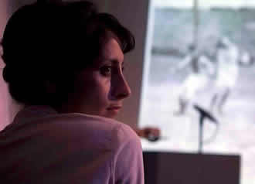
Shereen Martineau (Vyezhnova)
Shostakovich’s real-life biography has been surrounded by controversy, as historians and musicologists struggle over whether he was a loyal servant of the regime or a secret dissident.
To the world beyond the Soviet Union he appeared to be the former, until in 1979 a Russian émigré, Solomon Volkov, published a book claiming to be the composer’s “Testimony”. The book sold thousands of copies in the West and was both praised and denounced as a fraud.
Wondering how the regime might have responded to this book by reclaiming Shostakovich for its own, Sheldon enters the zone between the black and white of formal history written by winners, losers or those with an axe to grind. He achieves a many-sided presentation of the reality in which the composer lived. “We will be remembered by how we treat the memory of others,” is a phrase repeated twice in the play.
Shostakovich’s life was a continuous battle between resistance and capitulation. When his patron Marshall Tukachevsky was shot in the Great Purge of 1937, he put his 4th Symphony in the drawer, knowing it would get him into trouble with no-one to defend him. Yet he still went on producing innovative work, at a time when a poor review in Pravda was a matter of life and death.
Archives can be weeded, opened or closed and the number of biographies and counter-biographies of Shostakovich grow to outnumber the notes of music he wrote, but they are still his definitive autobiography.
Whilst some biographers have taken bar-by-bar political and sociological analysis to ludicrous extremes, nevertheless everything that Shostakovich felt and believed is there. No wonder Russians loved him so much, for he played their lives back to them, mediated through music.
Shostakovich was denounced again in 1948, along with Prokofiev, and the actor Yuri Lyubimov recalled that he would spend his nights sitting out on the landing with his suitcase so that at least his family would not be disturbed when the secret police came. But in the midst of Stalin’s post-war anti-Semitic terror he boldly published a song cycle of Jewish folk poems.
Would the man whose musical caricature of Stalin turned audiences pale with recognition have betrayed a friend to his death? Sheldon asks us to consider and accept or reject the possibility. After all – nothing can be proved.
The play is only on until April 17th – but that means there is still time to get over to Kilburn for the most lively and provocative experience of political theatre you are likely to have this year.
31 March 2010

